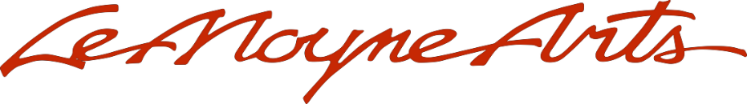
LeMoyne Arts Members Show 2021
Artist Application

ARTIST:___________________________________________________________________
MAILING ADDRESS: _________________________________________________________________
____________________________________________________________________________________
TELEPHONE NUMBER: _____________________________________________________________
E-MAIL ADDRESS:___________________________________________________________________

PRICING: the artist receives 60% of the selling price for works sold from LeMoyne. LeMoyne’s commission is 40%.

PUBLICITY: LeMoyne Arts makes every effort to advertise the exhibit. Unless notified in writing, LeMoyne will assume that the works in the exhibition may be photographed for reproduction in brochures, catalogs, news media, and other exhibit material.

ACCEPTANCE: If accepted, LeMoyne will request an Exhibition Agreement and W9 from the artist. LeMoyne reserves the right to refuse any submission deemed inappropriate for the exhibit.

- Title:
Dimensions:
Medium/Media:
Price:
Photos of Piece:

_______________________________________________________________________________________
- Title:
Dimensions:
Medium/Media:
Price:
Photos of Piece:

