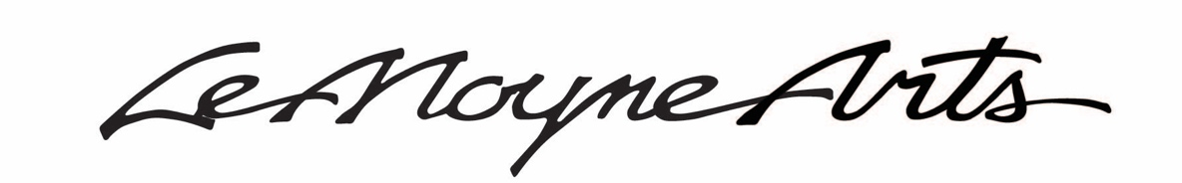
Sample Social Media Posts - #ArtForAlways
lemoyne.org/art-for-always

The CRA board approved LeMoyne’s application to change the scope of the Art for Always project to include the purchase and renovation of the adjacent Meyer Law firm building and funding of $1.8 Million for the project. Join me in voicing support for this project! For more info, visit lemoyne.org/art-for-always. #ArtForAlways

A new, larger, more accessible education building, and renovated sculpture garden will provide LeMoyne Arts with the facility it needs to be a regional magnet for arts education. Join me in voicing support for LeMoyne’s $1.8 Million CRA Arts, Culture and Heritage Grant approval! For more info, visit lemoyne.org/art-for-always. #ArtForAlways

A larger, more accessible LeMoyne art education building will draw regional and national conference participation, bringing more money to hotels, restaurants and other Tallahassee venues! Join me in voicing support for LeMoyne’s $1.8 Million CRA Arts, Culture and Heritage Grant approval! For more info, visit lemoyne.org/art-for-always. #ArtForAlways

LeMoyne employs 25 to 30 art teachers each year, providing a financial stimulus to artists and educators, making it possible for them to continue working in their chosen field creating art. A new art education building will provide opportunities for future generations of artists and art teachers to follow their dream! Join me in supporting LeMoyne’s $1.8 Million CRA Arts, Culture and Heritage Grant approval! For more info, visit lemoyne.org/art-for-always. #ArtForAlways

Voice your support for LeMoyne’s continued mission of Creating Community through Art by advocating for LeMoyne’s $1.8 Million CRA Arts, Culture and Heritage Grant approval to purchase a more accessible education center to better serve our community. For more info, visit lemoyne.org/art-for-always. #ArtForAlways

