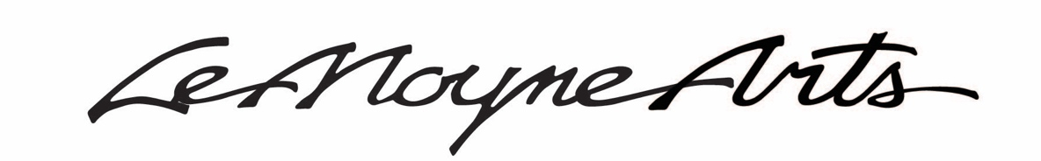
Sample Social Media Posts - #ArtForAlways
lemoyne.org/art-for-always

BREAKING NEWS! The CRA board approved LeMoyne’s application to change the scope of the Art for Always project to include the purchase and renovation of the adjacent Meyer Law firm building and funding of $1.8 Million for the project. We are thrilled and grateful, but there is still much to do. The next step will be receiving approval from the County Commission. Join me in voicing support for this project! For more info, visit lemoyne.org/art-for-always. #ArtForAlways

For nearly 60 years, LeMoyne Arts has been a Tallahassee cultural cornerstone! Join me in supporting LeMoyne’s $1.8 Million CRA Arts, Culture and Heritage Grant approval from the County Commission to purchase and renovate the adjoining Meyer Law firm building and convert it into a more accessible education center to better serve our community. For more info, visit lemoyne.org/art-for-always. #ArtForAlways

Since its creation, LeMoyne has fostered education and diversity in our community through its exhibits and Art Education Program. Artists who challenge us to think differently often find their voice through LeMoyne’s Art Education Program. Join me in supporting LeMoyne’s $1.8 Million CRA Arts, Culture and Heritage Grant approval from the County Commission to purchase a more accessible education center to better serve our community. For more info, visit lemoyne.org/art-for-always. #ArtForAlways

As a proud member of LeMoyne Arts for [insert number] years, I ask you to join me in supporting LeMoyne’s $1.8 Million CRA Arts, Culture and Heritage Grant approval from the County Commission to purchase and renovate the adjoining Meyer Law firm building and convert it into a more accessible education center to better serve our community. For more info, visit lemoyne.org/art-for-always. #ArtForAlways

Voice your support for LeMoyne’s continued mission of Creating Community through Art by advocating for LeMoyne’s $1.8 Million CRA Arts, Culture and Heritage Grant approval from the County Commission to purchase a more accessible education center to better serve our community. For more info, visit lemoyne.org/art-for-always. #ArtForAlways

